An Incredible Masters Record: 62 Seconds for 400 Meters at Age 60
Sue McDonald entered a new age bracket in 2023 and set nine world records.
BY SARAH LORGE BUTLER
PUBLISHED: DEC 22, 2023 2:59 PM EST

Rob Jerome

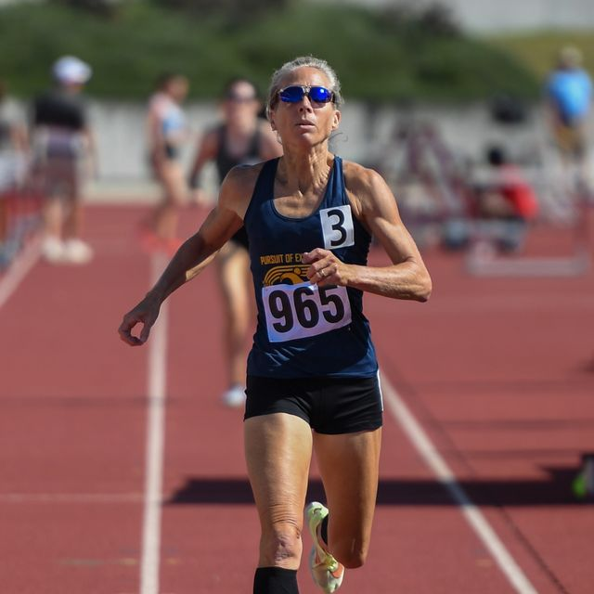
Sue McDonald turned 60 in March of 2023—and proceeded to rewrite the record book for her new age group. It’s hard to tell which of her nine world records was the most impressive.
A case could be made for the 5:28 she ran for the mile.
Or maybe it was the 2:22 for 800 meters.
Then there’s the jaw-dropper, the 62.34 for 400 meters she ran in July at the USATF Masters Championships in Greensboro, North Carolina.
Using a modified block start—McDonald quips that all the masters runners have different starts to accommodate their aches and pains—she broke the American record by more than 4 seconds and the previous world mark by almost 2 seconds.
The next-closest competitor in her age bracket was 15 seconds behind—almost 100 meters if run at McDonald’s pace.
Those performances, plus records in the 300-meter hurdles, 1500 meters, 2,000-meter steeplechase, and heptathlon, earned McDonald USATF Masters Athlete of the Year honors.
McDonald started her track career as a high jumper and heptathlete. Her best jump ever is 1.86 meters (6 feet, 1.25 inches). She later learned to pole vault and qualified for the 1996 Olympic Trials in that event.
Her athleticism is still evident. And McDonald’s coach, Terry Howell, who heads the Blue Collar Running group in Santa Barbara, California, thinks she can go even faster in 2024.
McDonald considers herself a long sprinter, and she doesn’t run much mileage. In 2023, she peaked at about 24 miles per week, with two days of workouts on the track or a hard-packed dirt path to keep her speed up. For the 2024 season, she’ll build up slightly, to about 28 miles per week.
“We touch on speed every week in some fashion, but at the same time we are working to increase my endurance so that I can hold my speed for longer,” she wrote in an email to Runner’s World.
McDonald works as a coach and personal trainer, primarily for masters athletes, coaching them remotely from her home in Santa Barbara.
She pays attention to the little things: Her extensive warmup includes running wickets almost every day. She’ll do a series of 20-second strides before and after most runs, too. Strength training is a core component of her routine, and she tells runners they’ll see results in about six weeks if they devote 20–30 minutes, three times a week, to strength. Not much equipment is needed, she said, but focus is. “Put your phone away,” she said.
She’s also a proponent of cross training and incorporates cycling, swimming, and deep water running into her routine. She tries to get seven to eight hours of sleep a night.
All in all, she said, “I don’t feel 60.”
In the year ahead, she hopes to improve upon her records, to make breaking them a little more difficult for the fast women she knows are soon entering her age group.
Howell, for one, is predicting big things. For 400 meters, maybe sub-61 at age 61.
“I think Sue will be better at 61, 62, 63 than she is now,” he said. “She has the potential. She’s kind of new to these events.”

SARAH LORGE BUTLER
Sarah Lorge Butler is a writer and editor living in Eugene, Oregon, and her stories about the sport, its trends, and fascinating individuals have appeared in Runner’s World since 2005. She is the author of two popular fitness books, Run Your Butt Off! and Walk Your Butt Off!

