

At 100, Dixon's Superpower Is Willpower
January 11, 2025
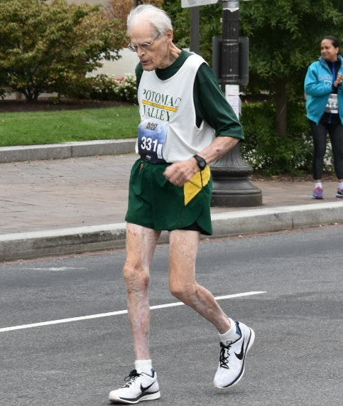
Dixon in his 90s doing what he loved. Running.

By Ray Glier
My friend Dixon Hemphill of Burke, Va., turned 100 yesterday, Jan. 10. It is his first birthday since the passing of his beloved wife, June, last spring.
Dixon was one of my first Geezer Jock stories in 2022. He started out as a pole vaulter in high school and college. Then he started running.
And he ran and ran and ran. From 5ks to Marathons, Dixon ran hundreds of races.
“It was attitude,” Dixon told me this week. “It was an attitude to love running. I was addicted to running.”
I asked him what his secret was to run up until he was 98.
“That’s it,” he said. “It was attitude.”
His most memorable moment, he said, came at 70 years old when he ran in Virginia Beach and qualified for The Boston Marathon. Hemphill ran the famous marathon in 3 hours, 44 minutes.
His next most memorable moment, to me, came during the Covid Pandemic, before the vaccine. He was 95. Dixon and June stayed inside their home rather than risk infection from a disease that was killing thousands.
He tried to use a stationary bike, but it was no use. Accustomed to running on the spongy indoor surface at George Mason University, Hemphill’s legs atrophied. He had to get around the house in a walker.
“I was worried I might not regain my ability to run again,” Hemphill said. “I was miserable.”
He didn’t want his last lap to be with a walker.
It wasn’t.
Dixon made his way back and competed again for the Potomac Valley Track Club.
I wrote in 2022:
“What Hemphill has going for him is a tangible intangible. Willpower. It is his anchor, which is a fitting metaphor for a Navy man (he was in WWII). Willpower can be invisible to others, but it has pulled many an athlete out of rut when they face serious odds.”
Hemphill's superpower is his willpower.
Happy Birthday Dixon!

Dixon and June at the finish line of another race.
……………………………………
Society has told you that you are too old for competitive sports. You’re not. Geezer Jock is a slap back at ageism. It celebrates older athletes and is storytelling about their triumphs. Brought to you every Saturday by a journalist obsessed with telling stories well. It’s FREE.

