INTERNATIONAL POLICY DIGEST

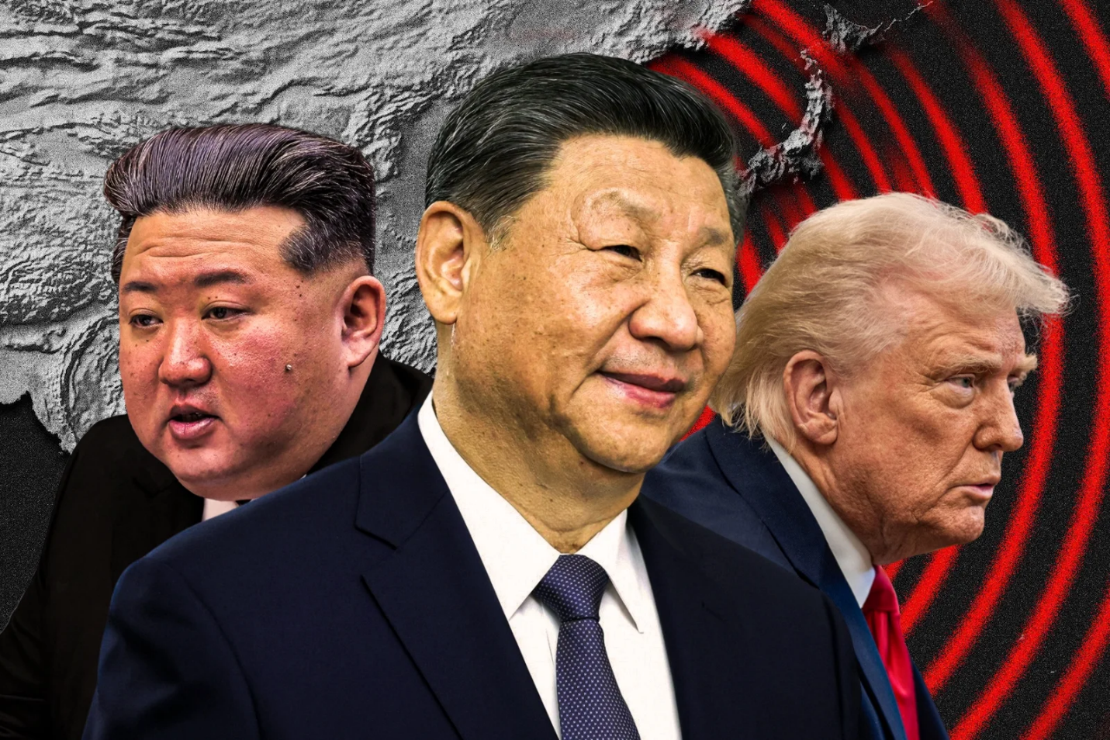World News / October 4, 2025

By Robert Weiner and Katherine White
Unmoored: Trump’s Neo-Isolationism and Beijing’s Rising Tide
As President Xi Jinping hosts Vladimir Putin and Kim Jong Un in Beijing—parading China’s military prowess—President Trump insists Americans shouldn’t be worried, saying in early September that China would “never use their military on us. Believe me.” A day later, he accused Beijing of “conspiring against” the United States. It isn’t a conspiracy. It’s strategy: a coordinated bid to tilt the global balance of power—this time without Washington at the center.
Katherine White
Robert Weiner
Under the Trump administration, U.S. foreign policy has leaned toward a neo-isolationist posture, shaking allies’ confidence and creating strategic slack that adversaries are eager to exploit. An unreliable American line only emboldens China—and its partners in Moscow and Pyongyang—to move into the vacuum created by U.S. drift.
That vacuum is most visible in the South China Sea, where Beijing is pressing its most ambitious agenda: control of vital waters through which roughly a third of global shipping passes. For the United States alone, sea traffic through the South China Sea has been valued at roughly $1.2 trillion in trade. The waterway isn’t just a map feature; it’s a supply-chain artery and a test of whether rules, not raw power, still govern the seas.
Historically, the United States has operated in these waters to prevent Chinese hegemony, reassure allies like South Korea, Japan, and the Philippines, and safeguard economic freedom. That role is not ornamental. It is deterrence made visible.
Beijing, meanwhile, advances its self-styled nine-dash line—an expansive claim that sweeps in up to 90 percent of the South China Sea and collides with the 1994 UN Convention on the Law of the Sea (UNCLOS), which recognizes territorial seas extending 12 nautical miles and exclusive economic zones out to 200 nautical miles. (China is a party to UNCLOS; the United States has not ratified it but generally observes its navigational principles.) China’s maximalist stance has strained Washington’s relationships with frontline partners and raised the risk of miscalculation at sea.
America’s internal rancor only strengthens Beijing’s hand. As President Trump elevates chaos and mixed messages into a foreign-policy method, Xi Jinping’s summit diplomacy binds his partners closer. Collisions between Philippine and Chinese vessels in August 2025 were not aberrations; they were symptoms of a worsening pattern.
The pattern extended on August 13, when China claimed it had “driven away” the USS Higgins near Scarborough Shoal—a pointed signal that Beijing feels emboldened, whether or not American warships are present. The trajectory is obvious: the more room China is given to press its claims, the more regional sovereignty is put at risk—and the closer Beijing comes to de facto hegemony in the South China Sea.
None of this is new in conception. Beijing has long practiced “salami-slicing”: small, cumulative moves—dredging a reef here, deploying a coast guard cutter there—that change facts on the water without provoking a large war. Scarborough Shoal, a small cluster of rocks and reefs, is a case study. So is China’s defiance of the 2016 South China Sea arbitration ruling, which found overwhelmingly for the Philippines and deemed much of China’s activity unlawful. The refusal to abide by an international tribunal isn’t an isolated legal spat. It’s part of a broader playbook—shared in spirit by Russia and North Korea—that treats norms as obstacles rather than guardrails.
As Russia prosecutes its war in Ukraine and courts Chinese support, it’s not hard to see Moscow drawing lessons from Beijing’s incrementalism. Nor is it difficult to imagine Pyongyang concluding that the moment is ripe for sharper provocations against Seoul. Strategic alignment among these three capitals does not require formal treaties to matter; it only requires shared opportunity.
The United States, then, faces an old choice in a newly perilous context: reassure allies with clear commitments and credible deterrence—or watch Beijing continue to carve the region into spheres of influence one slice at a time. If President Trump persists in neo-isolationism punctuated by erratic pronouncements, China will keep pushing outward, ship by ship, shoal by shoal. This is the moment to stiffen spines, enforce the law of the sea, and make unmistakably clear that unlawful expansion will not go unanswered.
If you're interested in writing for International Policy Digest - please send us an email via submissions@intpolicydigest.org

