
The PuLSE Institute
America's Anti-Poverty Voice
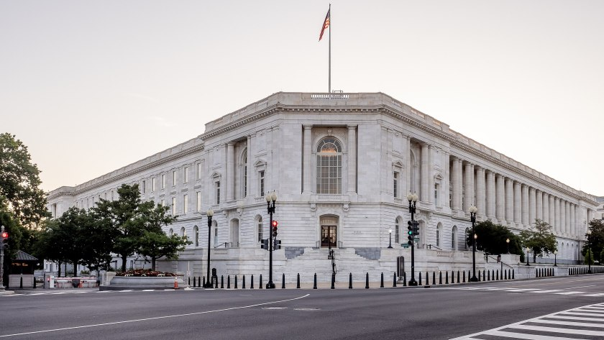
Thompson Doctrine for Corporate CEO's community responsibility: The New Senate Housing Bill Should be Applied
October 22, 2025
By Robert Weiner and Hallvard Misje
Across the United States, inequality has become the defining fault line of the economy. While corporate profits and stock prices reach record highs, millions of Americans face the daily struggle of finding affordable housing and stability. Leading journalist and standard-bearer for economic justice issues Bankole Thompson, who is the founder and dean of the anti-poverty think tank, The PuLSE Institute, has urged the country’s business leaders to confront this divide head-on.
Thompson’s emerging Doctrine which should be required reading for the nation’s business tycoons and business schools as well as the recent PuLSE economic conference which featured some CEOs as speakers call for a new standard of moral responsibility and economic justice in corporate America – one where CEOs, investors, and executives recognize that their success is inseparable from the well-being of the communities around them. Thompson warns of a growing distance between corporate boardrooms and the everyday realities of working families, arguing that business must become a force for social renewal rather than a detached observer of inequality.
“Though the nation’s captains of industry are not hired to be the moral leaders of their companies, it is incumbent on them to be men and women of conscience with a profound commitment to drive social change. This era is demanding conscientious corporate leaders who are committed to the issues of economic justice. Every leader of a major corporation must decide whether they will invest in the principles of economic justice where everyone has access to the opportunities that would lead to a dignified life,” Thompson explains in the didactic Doctrine. “Despite the longstanding argument that the mores and customs of the free market enterprise are not designed to fight the multidimensional poverty crisis facing communities across the nation, it is time for a paradigm shift in the role of the business leader in this age. A social impact business leader is one who is not only concerned about the profit wellbeing of their company, but also the economic health of the community in which they operate. The two are not mutually exclusive. They are mutually inclusive.”
Bob Weiner
The current ROAD to Housing Act offers corporate leaders a timely opportunity to begin changing their approach and aligning business conduct with broader social responsibility as laid out in the Bankole Thompson Doctrine. Advanced by the Senate Banking, Housing, and Urban Affairs Committee on a 24–0 vote – a rare moment of bipartisan consensus in today’s Congress – the Housing Act stands as the most comprehensive housing bills since the Great Recession.
It aims to boost affordability and expand supply while preserving local authority, cutting red tape, accelerating construction, and strengthening rental assistance programs to better support families and communities. Though the Congressional Budget Office has yet to release an official cost estimate, most analyses put the bill’s price tag at roughly $2.5 billion – a relatively modest sum for such an ambitious national initiative and miniscule compared to the Three TRILLION Dollars in tax breaks for billionaires in the BBB bill passed by both houses of congress and signed by President Donald Trump.
Part of the reason the bill sailed through committee is that it gives both sides something to claim as a win. For Republicans, it avoids federal preemption of local zoning and land-use authority, ensuring that decisions about development remain in local hands. It favors incentives over mandates, trims regulatory hurdles, and expands market-based tools such as financing for manufactured housing and investment in Opportunity Zones. These provisions are meant to make it easier for local governments and private developers to build – a move that could help increase supply and, eventually, ease prices. Changes in lending and regulation could also open the door to more manufactured homes, offering affordable relief for some communities.
For Democrats, the act delivers progress on core housing priorities. It expands affordable housing programs, strengthens tenant protections, and increases funding for HOME and other initiatives that support low-income families. With housing costs spiraling – home prices up more than 60 percent since 2019, and nearly half of renter households spending over 30 percent of their income on housing – the urgency of the crisis has forced a rare moment of cooperation. The ROAD to Housing Act marks the first bipartisan housing markup in more than a decade.
Still, experts warn that the legislation is not a cure-all. “It’s not a panacea,” said Alys Cohen, director of federal housing advocacy at the National Consumer Law Center, questioning whether the bill “will meet the needs of many of the people who need it the most – underserved communities and households of color.” Indeed, many households of color are disproportionately severely rent-burdened, paying more than half their income on rent.
A report from the Center for American Progress notes that regions with larger Black populations tend to have weaker safety nets and fewer protections for low-wage workers. Because these workers are disproportionately Black and brown, they are hit hardest by these gaps – though the effects ultimately ripple across all working-class communities.
This further underscores Bankole Thompson’s argument that the American economy needs a broader lift – one that extends beyond policy and includes corporations and the wealthy taking meaningful responsibility for the society from which they profit. His doctrine points toward a broader goal – creating solutions that lift all Americans, not just a privileged few – including those who may see little direct benefit from the Senate’s new housing bill.
Hallvard Misje
The bill could be especially helpful in Detroit, where abject poverty and abandoned houses still dominate the city’s media landscape.
Only when major political initiatives like the ROAD to Housing Act, private firms and investors, and ordinary Americans work together will there be a real chance to narrow the economic divides that define our society. The act is a promising start – a rare display of bipartisanship in times of lockdown.
But policy alone will not be enough. The effort must also come from the nation’s largest companies and financial institutions, and above all, it must endure. The groundwork has been laid; if future administrations build upon it rather than discard it, the country may finally begin to bridge its widening economic gaps.
Robert Weiner is a former spokesman in the Clinton and Bush White Houses and senior staff for Congressmen John Conyers, Charles Rangel, Claude Pepper, Ed Koch, Sen. Ted Kennedy, and 4-Star Gen. Barry McCaffrey. Bob is a member of The PuLSE National Advisory Board. Hallvard Misje is a Norwegian journalist and senior economic policy analyst at Robert Weiner Associates and the Solutions for Change Foundation.

