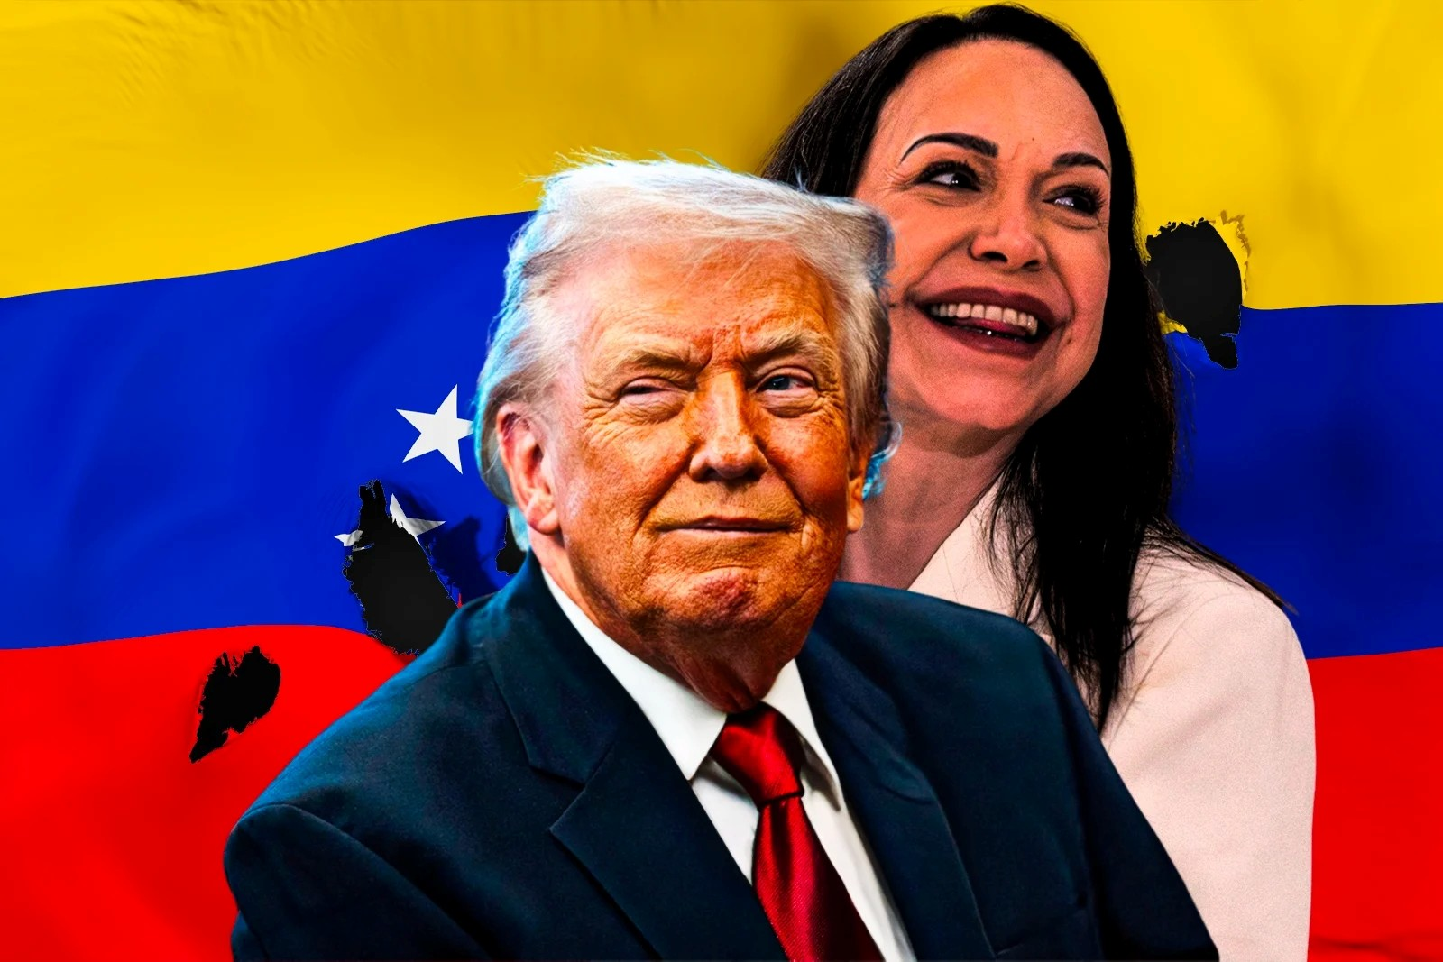
Photo illustration by John Lyman; Franziska Schminke

WORLD NEWS / FEBRUARY 15, 2026

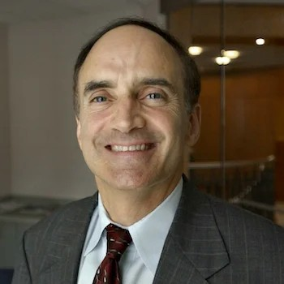 Robert Weiner 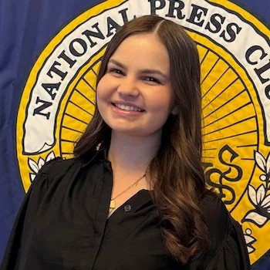 Emma Paris

Venezuela, Washington, and the Politics of Flattery

Hours after the U.S. military captured Venezuelan President Nicolás Maduro, President Donald Trump wasted little time clarifying what he believed was at stake in Venezuela. As NPR reported, he declared that “very large U.S. oil companies, the biggest anywhere in the world, go in, spend billions of dollars, fix the badly broken infrastructure, the oil infrastructure, and start making money for the country.” The candor was striking.

Stripped of the usual language about democratic restoration or hemispheric solidarity, the message was unmistakable. Washington’s Venezuela strategy was not, at its core, about ideology. It was about oil: the world’s largest proven reserves, billions of dollars owed to American firms, and the tantalizing prospect of reopening a sector that once pumped more than “3 million barrels a day.”

That framing dovetailed neatly with the White House’s January 5 statement celebrating Maduro’s arrest as a “remarkable foreign policy triumph.” With Maduro now facing trial in the United States, attention turned almost immediately to the question of succession. Who would govern Venezuela next—and, just as importantly, who would Washington bless?

Trump’s initial answer was Venezuela’s vice president, Delcy Rodríguez, Maduro’s constitutional successor. He publicly endorsed her as the legitimate interim president, signaling continuity over rupture.

According to Politico on January 14, Trump insisted that “we are making tremendous progress, as we help Venezuela stabilize and recover…we just had a great conversation today, and she’s a terrific person.” The subtext was clear: stability first. In a country whose institutions have been hollowed out and whose oil infrastructure has deteriorated after years of mismanagement and sanctions, political uncertainty could easily imperil the very investments Trump promised to revive.

The logic was not entirely unreasonable. Venezuela’s oil industry, though battered, remains what energy analysts call a “brownfield” opportunity—an established field where the reserves are known and the infrastructure, however degraded, can be rehabilitated. In such environments, companies have a relatively firm sense of what lies beneath the ground. They are not gambling on geological speculation; they are calculating refurbishment costs and political risk. For American firms eager to reclaim access to a once-lucrative market, that distinction matters. The administration’s early posture, therefore, suggested something pragmatic and transactional: secure a predictable political transition, restore production capacity, and reopen the door to American capital.

But that clarity proved fleeting.

Almost immediately, attention shifted to María Corina Machado, the long-time opposition leader whose name has become synonymous with anti-Chavista resistance. In the immediate aftermath of Maduro’s arrest, Trump appeared dismissive. According to The Hill, he remarked that “I think it would be very tough for her to be the leader. She doesn’t have the support within or the respect within the country.” It was a blunt assessment, but not an implausible one. Venezuela’s opposition has long been fragmented, its leaders alternately exiled, imprisoned, or disqualified. Even among Maduro’s critics, questions persist about whether any single figure can unify a polarized and economically devastated nation.

Then, almost as quickly, the tone changed.

Machado embarked on what could fairly be described as a carefully choreographed charm offensive. On January 15, she met with President Trump and presented him with her Nobel Peace Prize—a gesture laden with symbolism, particularly given Trump’s well-documented fascination with the award. According to NBC, she invoked one of his favored talking points, praising the wars he says he has ended since returning to office. The symbolism was unmistakable: recognition, admiration, validation.

The following day, Machado appeared at the Heritage Foundation, where she sharpened the parallels. In her remarks, she drew a direct line between her struggle against the Maduro regime and Trump’s own claims of electoral grievance. “We certainly talk about how popular sovereignty has been expressed in Venezuela and the absolutely terrible conditions in which we did and how the [Maduro] regime stole that result,” she said, adding that Trump “can certainly relate to that.” It was not merely diplomatic courtesy; it was rhetorical mirroring.

And it worked.

By Friday afternoon, the president’s posture had shifted. As NBC observed, “gone was any talk of disrespect.” Trump now spoke warmly of Machado, praising the “great meeting” he had with “a person who I have a lot of respect for—and she has respect, obviously, for me and our country—and she gave me her Nobel Prize.” He added, “I got to know her. I never met her before, and I was very, very impressed.

She’s a really—this is a fine woman…and we’ll be talking again.”

The swiftness of the reversal was striking. Only days earlier, Machado had been portrayed as lacking support and credibility. Now she was a respected interlocutor and potential partner. The transformation was not rooted in a new electoral mandate, a coalition agreement, or a detailed reconstruction plan. It followed a sequence of symbolic gestures and flattering comparisons.

This is not, of course, a novel pattern. Trump has often responded positively to leaders who echo his priorities or publicly affirm his stature. Machado appears to have understood that dynamic and engaged it directly. From her perspective, cultivating a personal rapport with the American president may be an entirely rational strategy. In a transitional moment when Washington’s backing could shape Venezuela’s political future, access matters.

The deeper concern lies not with Machado’s sincerity, but with the fragility of a foreign policy that appears susceptible to personal chemistry. Officially, the administration has neither withdrawn its support for Rodríguez nor formally anointed Machado. Institutions remain in place; diplomats continue their work. Yet presidential signals matter. Markets react to them. Allies interpret them. Domestic actors in Venezuela calculate around them.

If U.S. policy drifts from a strategy anchored in energy security and institutional stability toward one guided by personal affinity, the consequences could be profound. Washington risks aligning itself with a figure it has not fully vetted, in a country it has repeatedly misread. Venezuela’s political landscape is not a blank slate awaiting American endorsement. It is a dense web of military loyalties, regional power brokers, economic desperation, and public exhaustion. The legitimacy of any interim authority will hinge not on flattery exchanged in Washington, but on acceptance within Caracas and beyond.

There is also the matter of expectations. Should Machado emerge as Washington’s favored partner, she will be judged not only by Venezuelans but by American investors eager for rapid results. Reviving oil production from current depressed levels to anything approaching historical highs will require time, capital, and sustained political stability. It will demand security guarantees, regulatory clarity, and reconciliation among rival factions. None of those prerequisites can be conjured by personal rapport alone.

The United States has long struggled to balance its democratic rhetoric with its strategic interests in Latin America. In Venezuela, those tensions are on full display. The capture of Maduro offered an opportunity to articulate a coherent policy—one that acknowledged energy realities while insisting on institutional reform. Instead, the conversation has drifted toward personality.

Oil may have been the initial driver. Ego now threatens to become the accelerant. If Washington allows its Venezuela strategy to pivot on praise rather than policy, it will not only risk miscalculation abroad. It will also reinforce a perception that American foreign policy is less a matter of national interest than of personal affinity.

For a country as fragile as Venezuela, that is a dangerous foundation on which to build a new beginning.

