

Opinion: Long-term unemployment adds to nation's job crisis
Robert Weiner and Andrew Beauchamp
March 4, 2026, 7:21 a.m. ET
Former Rep. John Conyers, who represented Detroit, secured reelection in 25 successive campaigns and served 52 years with "jobs" as his primary issue ― he regularly asserted, “Full employment is the first priority.”
Even though it seems like an obvious win for workers everywhere, the hiking of the minimum wage is only an aspiration, a dream, a hope for the average American who can’t get a job. This comes as many states, 19 in fact, raised the minimum wage.
The U.S. Bureau of Labor Statistics (BLS) reported in the BLS annual benchmark that only 181,000 jobs were added to the U.S. economy in 2025. Spread out over every state in the U.S. over one year, that means that only approximately 300 jobs were added per state, per month.
The virtually ignored issue is long-term unemployment, but it is the most painful to the workers and their families involved. The popular definition among journalists is that long-term unemployment occurs when an individual experiences a jobless period that lasts longer than the maximum duration for which someone can receive unemployment benefits. This typically ranges from 14 to 26 weeks, or about six months. Even when someone receives these benefits, the income usually accounts for only 40% or lower of their original income.
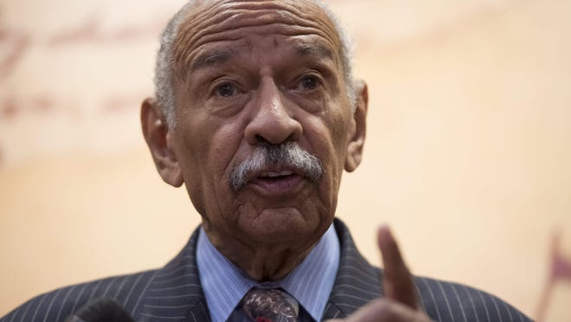
Making the long-term unemployment issue even worse is a low-hire, low-fire environment. The BLS also reported a decrease in job openings, from 11 million in March 2022 to only six million five hundred thousand in December 2025. The American job economy is now one where workers who both lose their jobs and those entering the job market cannot find work, leading to long-term unemployment.
A total of about 183,000 people nationally exhausted their unemployment benefits on December 31, per the Department of Labor. That is 2,000 people more than the number of jobs added in the total of that calendar year.
Detroit, and Wayne County at large, suffered from a stark increase, from one in 10 individuals exhausting their benefits in 2023 to one in three in late 2025, according to the Michigan Unemployment Insurance Agency (MUI). In total, around 83,000 individuals exhausted their funds in just December 2025, per the MUI. Higher wages motivate more people to enter the labor market with the promise of more money.
As Pulitzer-Prize winning journalist Antonia Hylton said on MS NOW in January, "If you're out of a job in America, you're having a hell of a time finding one." While it is a good cause, shouldn’t Congress and the president be focusing on job opportunities for the long-term unemployed in tandem with job growth and raising the minimum wage? Even with large jumps, one without the others leads to an inaccessible job market for those who have suffered the longest.
Most states and the Congress have failed to pass legislation to effectively stimulate the job economy, dampening the success of achieving a higher minimum wage. To effectively fix the labor situation in America, we must follow Conyers’ words and secure full employment ― or wins like higher wages won’t matter to unemployed Americans.
Robert Weiner is the former spokesman and Director of Public Affairs for the House Government Operations and Judiciary committees under Chairman John Conyers (D-Detroit), as well as a former senior staffer in the Clinton and Bush White Houses and for Reps. Charles Rangel, Ed Koch, Claude Pepper, Sen. Ted Kennedy, and Four-Star Gen./U.S. Drug Czar Barry McCaffrey. Andrew Beauchamp is a research and policy analyst at Robert Weiner Associates and the Solutions for Change Foundation.

