
The PuLSE Institute
America's Anti-Poverty Voice

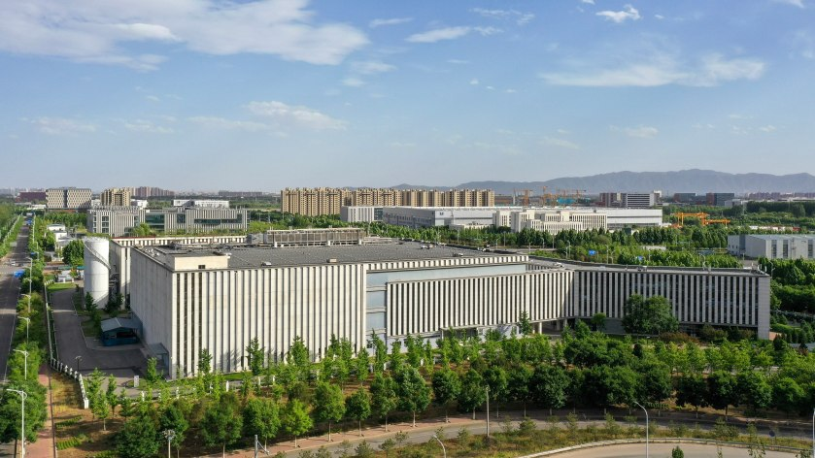
Will Data Centers Increase or Decrease Poverty in Detroit and America?
September 21, 2026
thepulseinstitute
By Robert Weiner and Jaylen Hill

In a Truth Social post, President Donald Trump claimed data centers were a “golden goose” that will make voters become “rich and successful.” The evidence, on the other hand, reveals a trajectory that could leave communities paying more than they receive.

Across the country, data centers are coming under increased scrutiny, even by politicians who once championed them. A recent NBC News poll found that nearly 70% of respondents oppose AI data centers. It appears tax incentives, temporary jobs and the race with China are no longer enough to justify the rising utility bills, copious water usage and local pollution that data centers entail.
The PuLSE Institute is playing a leadership role in bringing together leaders on the issue of data centers.

A key question: Will data centers increase or decrease poverty in Detroit and America.

As roughly a third of Detroiters live below the federal poverty level, the encroaching construction of data centers in their communities poses a threat to economically disadvantaged locals.
Earlier this year the Stargate Project refused to comply with a Saline Township board vote that vetoed plans for a $16 billion AI data center — they sued, and construction began anyway. Although the township was able to secure few community benefits, the community didn’t want the facility to begin with.

With over 70 across the state — and 35 in Detroit — Michigan is no stranger to data centers. But if the will of the people can be disregarded and trumped by the wealth of corporations, the problem may go further than just data centers.

Robert Weiner

Wisconsin is also becoming a case-study in the national data center fight as the topic is put center stage in the gubernatorial race. Large corporations like Microsoft, Meta and Oracle have already spent billions to build data centers across the state.

The growing concern of Wisconsinites is shown through the latest Marquette Law School poll that saw 71% of adults oppose data centers.

The question is not whether data centers create economic opportunities. It’s who reaps the benefits and who absorbs the costs.

Data center-related promises are coming under fire as critics highlight the threat centers pose to communities facing poverty and a general misunderstanding of what data centers are.
Data centers are large, highly secured buildings that act as the physical infrastructure of the internet, or “the cloud.” They house servers, networking equipment and other supporting systems like cooling. Centers can range in size from a room in an office building to the size of multiple football fields, called “hyperscale data centers.”

Although the cloud is digital, it isn’t weightless, and its costs are intensely physical.

In exchange for billions of dollars in infrastructure that corporations spend, local communities provide resources like electricity, water, land, tax incentives, and other public services.
Scholars predict that data centers could represent up to 12% of U.S. electric consumption by 2028. They have already contributed to an over $60 billion in rate increases across the country in 2025. Another of the attributing reasons is the need to build new energy infrastructure for data centers in regions whose grids cannot provide the necessary output. This is one of the major drawbacks associated with data centers that is often mentioned yet rarely explained.

Jaylen Hill

Mid-sized facilities can use up to 300,000 gallons of water daily, while large ones consume around 5 million gallons a day — comparable to a small town. This data point is especially concerning as two-thirds of all data centers either built or developing, since 2022, are located in “water-stressed” areas like Arizona and Texas. While a facility’s water usage is determined by factors like size, location and internal cooling methods, it is imperative to understand the role data centers can play in water insecurity without necessary oversight and guardrails.

While it is true that data centers do generate economic activity, their benefits up to date are simply overstated. These benefits include employment, local investment and tax revenue.

Data center construction can create hundreds of temporary jobs for a range of trade workers, while usually only supporting 25–150 permanent workers. Meanwhile, communities can be left to bear the cost of water and electrical infrastructure left from centers that choose to relocate, downsize or cease operations.

So, who truly benefits from the billions being spent?

In a recent article, Bankole Thompson, founder and chairman of the PuLSE Institute, spoke to the impending threat of data centers on vulnerable communities.

“Innovation can transform an economy, but leadership determines whom that transformation serves. The moral question is whether this extraordinary new economy will enlarge the circle of opportunity or create another frontier of prosperity that millions can see but never enter,” Thompson said.
As politicians and corporations continue to push us toward an age of AI, anti-data center sentiments continue to grow. Communities should not have to gamble their water, electricity bills and infrastructure to subsidize companies.

Creating policies that include dedicated utility rate structures, cost recovery, water monitoring, transparent siting and community-benefits agreements can help to shape a fair bargain for local communities.

A golden goose is only valuable if the person receiving the eggs isn’t paying more to feed it than the eggs are worth.

Robert Weiner is president of Robert Weiner Associates in Washington, D.C. He is a former spokesman for the Clinton and Bush White Houses, a chief of staff to U. S. Rep. Claude Pepper, and long-time senior staff for Rep. John Conyers, Charles Rangel, Ed Koch, Sen. Ted Kennedy, and Four-Star General/Drug Czar Barry McCaffrey. He is a National Advisory Board member and winner of the Conscience of Democracy Award for the PuLSE Institute, and winner of the National Press Club President’s Award for recruiting young journalists as co-bylined op-ed writers (1100+ articles).

Jaylen Hill is a senior economic policy and research analyst at Robert Weiner Associates and the Solutions for Change Foundation. He is a student at Marquette University majoring in English and Spanish Literature. As an aspiring attorney, he is passionate about advocating for the marginalized.

